Q: A1.  Use CREATE  statement to create a table Client (ClientName,  phone). Note ClientName is primary key and you must define this primary key in CREATE statement. Show the statement.

🡪  
Create table Client

( ClientName VARCHAR (25),

Phone INT,

CONSTRAINT PK_Client PRIMARY KEY (ClientName) ) ;

🡪

Q: A2.  Use ALTER statements to add a foreign key *ClientName* into the Project table. So that table Client has a one  to many relationship with table Project. Note, you need to use TWO ALTER statements , one  for adding ClientName into Project table; one for adding foreign key constraint into Project table.  Show the ALTER statements.

🡪

Alter Table Project

Add ClientName Varchar(25)

Alter table Project

Add constraint project_clientName_fk

Foreign key (ClientName) references Client (ClientName)

🡪

Q: A3. User ALTER statement to Add an attribute Project_Count into Employee table (data type to be integer, refer to the data type used for Workon table (hours)  in loadDB file).

🡪  
Alter Table Employee

Add Project_Count INT

🡪

Q: A4. Use UPDATE statement to fill the value of Project_count of each employee record in Employee table. Namely, add the count of total number of projects an employee works on into Project_count in Employee table for each employee.  Hint: you need a subquery in Update statement as follows

  Update _________

  Set _____ = (select count (pid) ...... )

Show the contents of Employee after update.

🡪  
Update Employee e

Set Project_Count = (select count (pid) as countPID From Workon w, employee ee where w.empid = e.empid and e.empid = ee.empid )

🡪

Q: A5 Create a table Promotion_list (EMPID, Name, Salary, DivisionName).

🡪  
Create Table Promotion_List

(Empid INT, Name Varchar (30) , Salary Float, Dname Varchar (25), constraint PK_promotion_list Primary Key (Empid) )

🡪  


Q: A6 Load Promotion_list with the information of employees who make less than company average and work on at least 2 projects. (Hint use INSERT INTO SELECT statement ). Show the code and result.   
  
🡪  
Insert into promotion_list

Select Empid, Name, Salary, Dname

from employee e, division d

where d.did = e.did

and salary < (select avg(salary) from employee ee) and e.empid in (select w.empid from workon w group by w.empid having count(pid) >= 2)

🡪  
Select * from promotion_list

🡪  
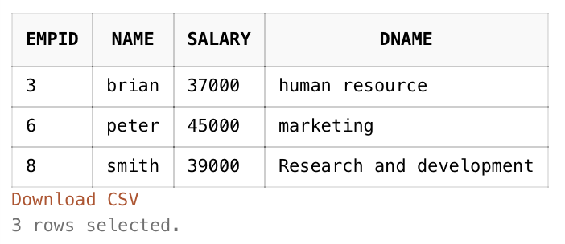

**Part B**

Q: B1. Increase the budget of a project by 5% if there is a manager working on it.

🡪  
Update project P

Set Budget = Budget + (budget*0.05)

Where P.pid in ( select w.pid from workon w join employee e on e.empid = w.empid join division d on d.did = e.did where d.managerid = w.empid)

🡪  
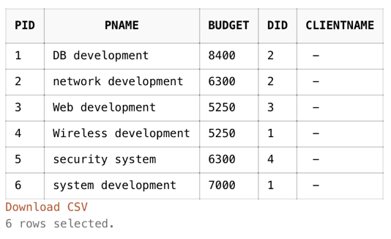

Q: B2. List the name of employee who work on a project sponsored by his/her own division. (corelated subquery)

🡪  
Select Distinct E.Name

from Employee E

Where E.empid in ( select e.empid from workon w join employee ee on e.empid = w.empid join project p on p.pid = w.pid where p.did = e.did )

🡪  
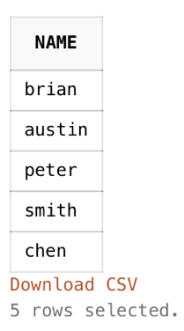

Q: B3. List the name of project that has budget that is higher than ALL projects from 'marketing' division.

🡪  
Select p.pname

from project p

where p.budget > (select pp.budget from project pp where pp.budget in ( select max(ppp.budget) from project ppp, division d where d.did=ppp.did

and lower (d.dname) = 'marketing'))

🡪

Q: B4. List the name of project that has budget that are higher than ALL projects from 'chen's division.

🡪  
Select p.Pname

from project p

where p.budget > (Select max(pp.budget) from project pp join employee e on e.did = pp.did where lower(e.name) = 'chen')

🡪

Q: B5. List the name of employee who work on more projects than employee 'chen'    
  
🡪  
Select E.name

from employee e

where e.empid in ( select w.empid from workon w group by W.empid having count(w.pid) >

(select count(ww.pid) from workon ww join employee ee on ee.empid = ww.empid where lower (ee.name) = 'chen') )

🡪

Q: B6. List The name of division that has employee(s) who work on other division's project .  (corelated subquery)

🡪

Select distinct Dname

from division d

join employee e

on d.did = e.did

Where e.empid in (select ee.empid from workon w

join employee ee

on w.empid = ee.empid

join project p

on p.pid = w.pid

where e.did = ee.did and p.did <> e.did)  
  
🡪  
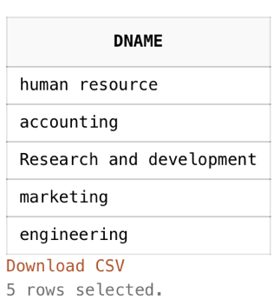

Q: B7.  List the name of employee who works ONLY with his/her divisional colleagues on project(s).  (Hint, namely, the employee (e) firstly works on project(s) , and secondly, there NOT EXISTS a project that  e  works on and another employee (ee) also works on  but they are from different divisions.)

🡪

Select Name

from Employee e

where exists (select e.empid from workon w, employee ee where ee.empid = w.empid and e.did = ee.did and

not exists ( select ww.pid from workon ww join project p on p.pid = ww.pid where p.pid = w.pid ))

🡪  
